**CODE**

**TCPServer**

import java.io.*;

import java.net.*;

public class tcpserver {

public static void main(String[] args) throws Exception {

ServerSocket ssock = new ServerSocket(5000);

Socket socket = ssock.accept();

InetAddress IA = InetAddress.getByName("localhost");

File file = new File("hello.txt");

FileInputStream fis = new FileInputStream(file);

BufferedInputStream bis = new BufferedInputStream(fis);

OutputStream os = socket.getOutputStream();

byte[] contents;

long fileLength = file.length();

long current = 0;

long start = System.nanoTime();

while(current!=fileLength){

int size = 10000;

if(fileLength - current >= size)

current += size;

else{

size = (int)(fileLength - current);

current = fileLength;

}

contents = new byte[size];

bis.read(contents, 0, size);

os.write(contents);

System.out.print("Sending file ... "+(current*100)/fileLength+"% complete!");

}

os.flush();

socket.close();

ssock.close();

System.out.println("File sent succesfully!");

}

}

**OUTPUT**

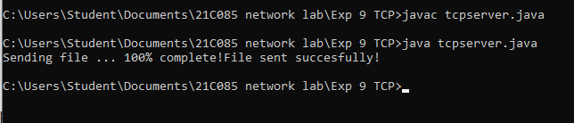

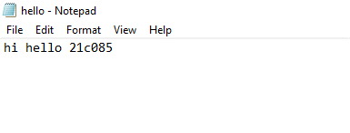

**CODE**

**TCPClient**

import java.io.BufferedOutputStream;

import java.io.FileOutputStream;

import java.io.InputStream;

import java.net.InetAddress;

import java.net.Socket;

public class tcpclient {

public static void main(String[] args) throws Exception{

Socket socket = new Socket(InetAddress.getByName("localhost"), 5000);

byte[] contents = new byte[10000];

FileOutputStream fos = new FileOutputStream("fromServer.txt");

BufferedOutputStream bos = new BufferedOutputStream(fos);

InputStream is = socket.getInputStream();

int bytesRead = 0;

while((bytesRead=is.read(contents))!=-1)

bos.write(contents, 0, bytesRead);

bos.flush();

socket.close();

System.out.println("File saved successfully!");

}

}

**OUTPUT**

